Experiment 5

System Information Commands

Aim
To execute uptime, date, and mv commands.

Theory

uptime Command
Shows system running time.
Uptime

date Command
Displays current date and time.
Date

mv Command
Moves or renames files.
mv file1.txt file2.txt

Procedure
- Check system uptime.
- Display current date.
- Rename a file using mv.

Output:
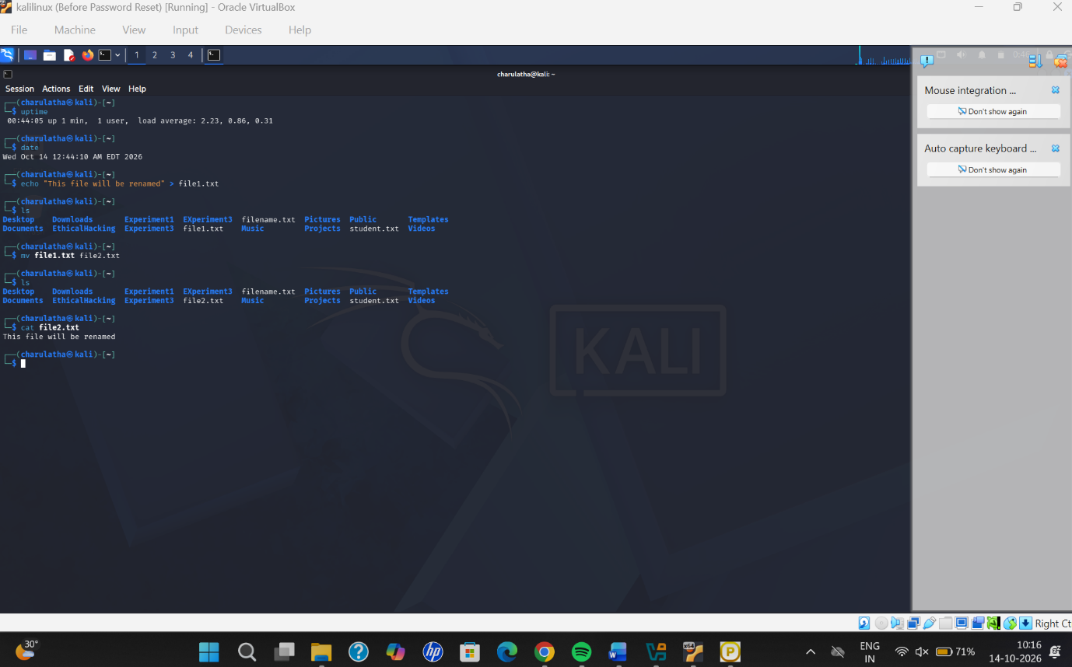

Result
Successfully executed uptime, date, and mv commands.

